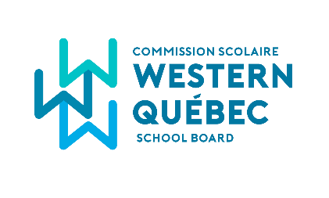
2025 – 2026 EXAMINATION REGISTRATION FORM
Secondary 5

- If you are requesting adaptations to the conditions of administration of examinations, then please:
- Put a check mark in the last column: Adaptations requested, and;
- Fill in the form entitled “Request for Adapting the Conditions for Administering a Ministerial Examination” and return it along with the Examination Registration form to: homeschooling@wqsb.qc.ca

Child’s Name:
Permanent Code:
Child’ s Address:

Parent’s Name:
Parent Phone Number:

MANDATORY MINISTRY EXAMINATIONS – SECONDARY 5

Exam Registration | Course Title | Course Code | Exam Date | Exam Time | Adaptations requested
 | English Language Arts Reading  Secondary 5 | 612-520 | May 27 | 9h-11h30
 | English Language Arts Production Preparation  Secondary 5 | 612-530 | May 27 | From 11h45
 | English Language Arts Production Writing  Secondary 5 | 612-530 | May 28 | 9h-12h
 | French Second Language (Base) Modalités d’évaluation  Secondary 5 | 634-510 | Document pick-up between May 12 and May 16 | By appointment
 | French Second Language (Base) Activité préparatoire et Interaction orale  Secondary 5 | 634-510 | Between May 22 and June 12 | By appointment
 | French Second Language (Base) Activité préparatoire et Compréhension écrite  Secondary 5 | 634-520 | May 21 | 9h-12h
 | French Second Language (Base) Production écrite  Secondary 5 | 634-530 | June 12 | 9h30-11h30
 | French Second Language (Enrichi) Modalités d’évaluation  Secondary 5 | 635-520 | Document pick-up between May 12 and June 4 | By appointment
 | French Second Language (Enrichi) Activité préparatoire et Compréhension écrite  Secondary 5 | 635-520 | June 5 | 9h-12h
 | French Second Language (Enrichi) Production écrite  Secondary 5 | 635-530 | June 6 | 9h-12h

OTHE
OTHER EVALUATIONS AVAILABLE FOR CHILDREN WHO WANT TO OBTAIN A SECONDARY SCHOOL DIPLOMA
Secondary 5
 | Mathematics CST  Secondary 5 | 563-504 | TBD | TBD
 | Mathematics SN  Secondary 5 | 565-506 | TBD | TBD
 | Physical Education & Health  Secondary 5 | 543-502 | TBD | TBD
 | Culture and Citizenship in Québec  Secondary 5 | 569-502 | TBD | TBD
 | Arts – Visual Arts  Secondary 5 | 668-502 | TBD | TBD
 | Financial Education  Secondary 5 | 602-522 | TBD | TBD
 | Contemporary World  Secondary 5 | 592-502 | TBD | TBD
 | Chemistry  Secondary 5 | 551-504 | TBD | TBD
 | Physics  Secondary 5 | 553-504 | TBD | TBD

RTIONS AVAILABLE FOR CHILDREN WHO WANT TO OBTAIN A SECONDARY SCHOOL DIPLOMA
I confirm that my child will be present for the evaluation(s) that I have requested through this form.

Parent’s Signature:
Date:

Please return this form (along with your child’s Learning Project and the form entitled Request for Adapting the Conditions for Administering a Ministerial Examination, if requested) to:
homeschooling@wqsb.qc.ca

If you have questions about Sanction Ministry Examinations, please send an e-mail to:
homeschooling@wqsb.qc.ca

