Thursday, December 14, 2023

Dear Parents/Guardians and Students,

I write to you today to confirm that all WQSB schools and centres return to regular operation tomorrow, December 15th. While employees of other unions outside our school board may continue being on strike in the Outaouais region, WQSB employees will be back to work starting tomorrow morning. All buses will be operating, and daycares will be open.

Please note that I will continue to provide updates regarding the status of WQSB schools and centres if needed.

Respectfully,

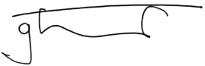
George Singfield
Directeur général
Director General


